SHS Robotics Website Update

The website has not been updated in two years and is in desperate need of refreshing. Take a look at how other team’s design their website & organize their data (33, 71, 195, 254, 1519 are good places to start). Recommend the following sections (**heading labels below**) with the suggested content below……………

# Home:

Team Logo’s

Team Picture

Document where we are competing in 2018 – Granite State District & UNH District (venue pictures?)

Section to update latest Entropy news from Entropy (something we refresh with frequency, pictures, blog?)?

Team calendar (meetings that are updated, community events, competitions, etc.)?

# About Us:

The Souhegan High School proudly sponsors the FIRST Robotics Team 138 - “Entropy”, founded in 1996. Entropy is group of students interested in the fields of business, engineering, math, and science. With the help of adult mentors, the team designs & builds a robot to compete in the FIRST Robotics Competition. Our team starts meeting in early October and wraps up the year with a team awards banquet in May.

Team Awards:

| *Year* | *FIRST Event* | *FIRST Awards* |
| --- | --- | --- |
| 2002 | UTC New England Regional | Leadership in Controls Award |
| 2004 | Granite State Regional | Granite State Regional Finalist |
| 2005 | Granite State Regional | Granite State Regional Finalist  Radio Shack Innovation in Control Award  Website Excellence Award |
| 2006 | Granite State Regional | Delphi Driving Tomorrow's Technology Award |
| 2007 | Granite State Regional | AutoDesk Visualization Award |
| 2008 | Granite State Regional | AutoDesk Visualization Award  Website Excellence Award |
| 2009 | Granite State Regional | AutoDesk Visualization Award |
| 2011 | North Carolina Regional | North Carolina Regional Finalist |
| 2014 | Granite State District  NE Championship Qualifier | Granite State District Winner  Industrial Design by General Motors |
| 2015 | Granite State District  UNH District  NE Championship Qualifier  World Championship Qualifier | Granite State District Finalist  Industrial Design by General Motors  UNH Judges Award |
| 2016 | Granite State District  NE Championship Qualifier | Granite State Judges Award |

Contact Us:

Robotics team email - roboticsteam138@gmail.com

Lead mentor email (Brian Walters) – bfwalters@comcast.net

Souhegan High School contact (Pam Paul) email – ppaul@sprise.com

# FIRST:

Include FIRST & FRC logos

FIRST FRC home page - [www.firstinspires.org/robotics/frc](http://www.firstinspires.org/robotics/frc)

NE FIRST - nefirst.org/

SHS Robotics Team Axioms:

What WINS in FIRST?

•Working as a team to achieve a common goal

•Collaborating on ideas to solve a complex problem

•Decompose a complex activity into a manageable set of tasks

•Learning to operate in a constrained environment practicing time management skills

•Behaving in the spirit of “Gracious Professionalism” and “Coopertition”

What WINS FIRST Competitions?

•Proficient drive team – practice, practice, practice!

•Sound game strategy augmented with informed scouting feedback

•Competitive robot design – do one thing very well!

•Good alliance partners – luck of the draw!

Define what is “Gracious Professionalism” and “Coopertition” (on the current website)

Current Game Animation:

Start with 2017 Steamworks Animation (replace with 2018 PowerUp animation when released)

Current Game Description:

Start with 2017 Steamworks Description (replace with 2018 PowerUp description when released)

# Sponsorships:

Include corporate logos & links to our corporate sponsors

Team mentor picture



[](http://www.rockwellautomation.com/)[](http://www.sprise.com/default.aspx)

[](http://www.rapidsheetmetal.com/index.aspx)   [](http://www.datron.com/index.php)

***John Albert Welding Services***

***BB Molding Company***

# Past Robots:

Include brief game description (go to FIRST website & get the game description (usually section 1) from the game manual) with past robot pictures & links to key competition videos

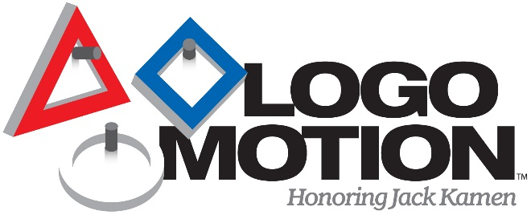LOGO MOTION is played by two competing alliances on a flat 27’ x 54’ foot field. Each alliance consists of three robots. They compete to hang as many inflated plastic shapes (triangles, circles, and squares) on their grids as they can during a 2 minute and 15 second match. The higher the teams hang their game pieces on their scoring grid, the more points their alliance receives.

The match begins with one 15-second Autonomous Period in which robots operate independently of driver inputs and must hang Ubertubes to score extra points. For the rest of the match, drivers control robots and try to maximize their alliance score by hanging as many logo pieces as possible. Any logo piece hung on the same peg as an Ubertube receives double points. If teams assemble the logo pieces on their scoring grids to form the FIRST logo (triangle, circle, square, in a horizontal row in that order), the points for the entire row are doubled.

The match ends with robots deploying minibots, small electro-mechanical assemblies that are independent of the host robot, onto vertical poles. The minibots race to the top of the pole to trigger a sensor and earn additional bonus points.

2011 LogoMotion Robot – North Carolina Regional Finalist

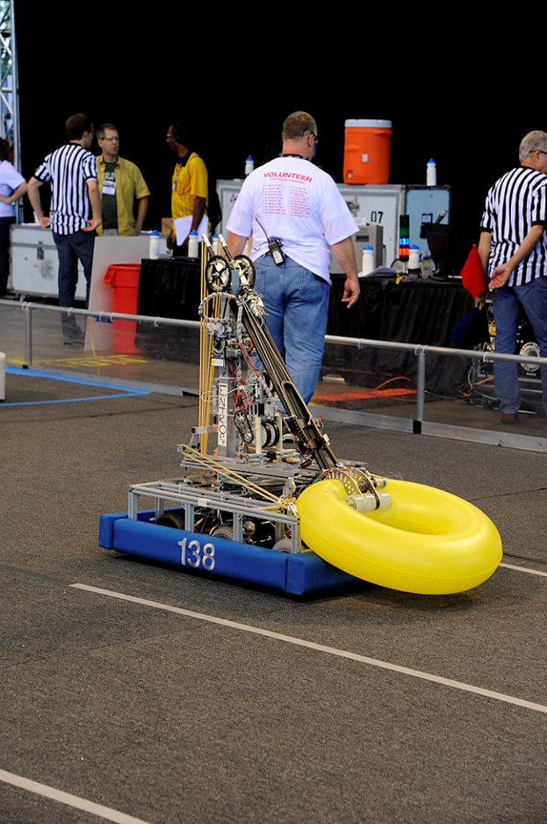

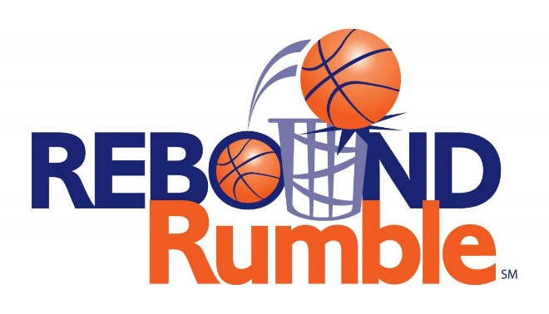 Rebound Rumble is played by two competing Alliances on a flat, 27 x 54 foot field. Each Alliance consists of three robots. They compete to score as many basketballs into their hoops as they can during a 2 minute and 15 second match. The higher the hoop in which the basketball is scored, the more points the Alliance receives.

The match begins with a 15-second Hybrid Period in which robots operate independently of driver inputs. During this Hybrid Period, one robot on each Alliance may be controlled using a Microsoft Kinect. Baskets scored during this period are worth extra points. For the remainder of the match, drivers control robots and try to maximize their Alliance score by scoring as many baskets as possible.

The match ends with robots attempting to balance on bridges located at the middle of the field. In Qualification Matches, a robot from each Alliance will also try to balance on the white Coopertition™ bridge to score additional ranking points for each Alliance.

2012 Rebound Rumble Robot

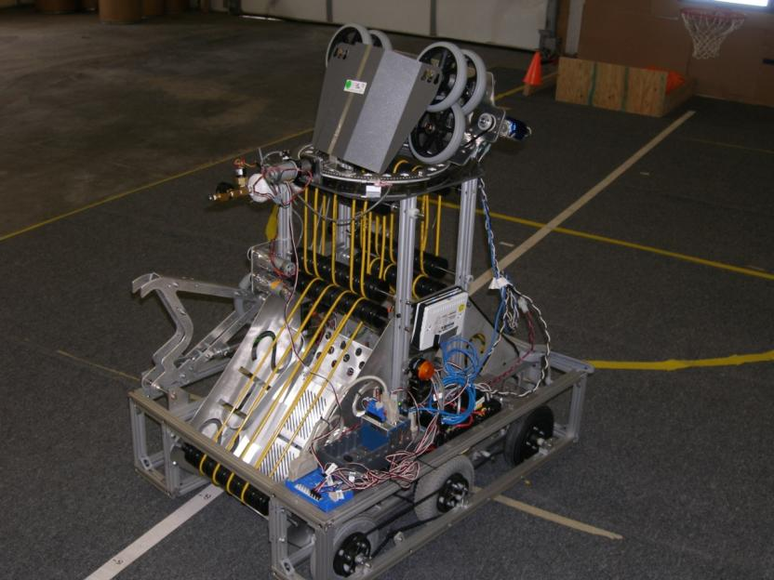

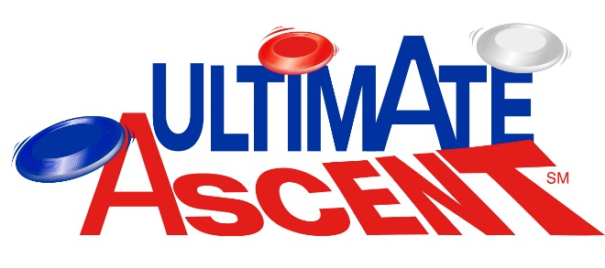 ULTIMATE ASCENT is played by two competing alliances on a flat, 27 x 54 foot field. Each Alliance consists of three robots, and they compete to score as many discs into their goals as they can during a two (2)-minute and fifteen (15)-second match. The higher the goal in which the disc is scored, the more points the Alliance receives.

The match begins with a fifteen (15)-second Autonomous Period in which robots operate independently of driver inputs. Discs scored during this period are worth additional points. For the remainder of the match, drivers control robots and try to maximize their alliance score by scoring as many goals as possible.

The match ends with robots attempting to climb up pyramids located near the middle of the field. Each robot earns points based on how high it climbs.

2013 Ultimate Ascent Robot

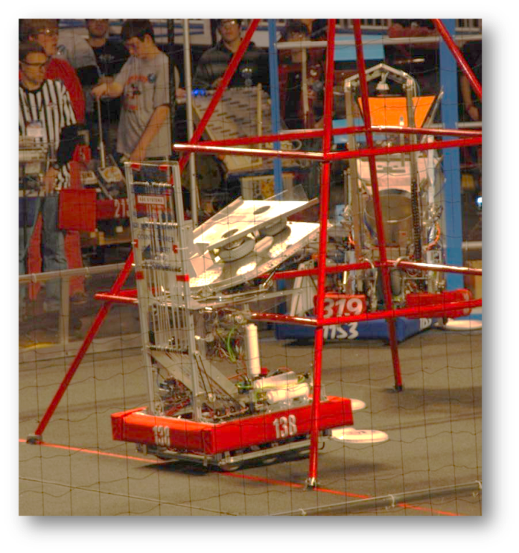

 AERIAL ASSIST is played by two competing Alliances of three robots each on a flat 25’ x 54’ foot field, straddled by a truss suspended just over five feet above the floor. The objective is to score as many balls in goals as possible during a two (2)-minute and 30-second match. The more Alliances score their ball in their goals, and the more they work together to do it, the more points their Alliance receives.

The match begins with one 10-second Autonomous Period in which robots operate independently of driver. Each robot may begin with a ball and attempt to score it in a goal. Alliances earn bonus points for scoring balls in this mode and for any of their robots that move in to their zones. Additionally, each high/low pair of goals will be designated “hot” for five seconds, but the order of which side is first is randomized. For each ball scored in a “hot” goal, the Alliance earns additional bonus points.

For the rest of the match, drivers remotely control robots from behind a protective wall. Once all balls in autonomous are scored, only one ball is re-entered in to play, and the Alliances must cycle a single ball as many times as possible for the remainder of the match. With the single ball, they try to maximize their points earned by throwing balls over the truss, catching balls launched over the truss, and scoring in the high and low goals on the far side of the field. Alliances receive large bonuses for “assists,” which are earned for each robot that has possession of the ball in a zone as the ball moves down the field.

2014 Robot –Granite State District Champion; NE Championship Qualifier

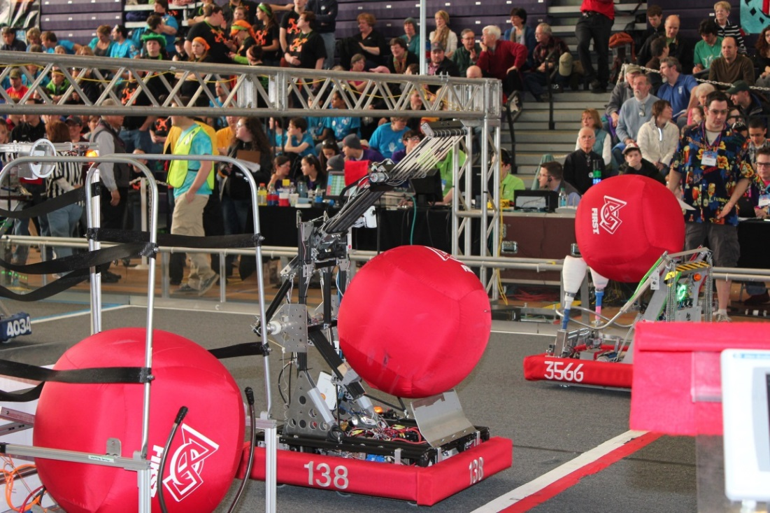

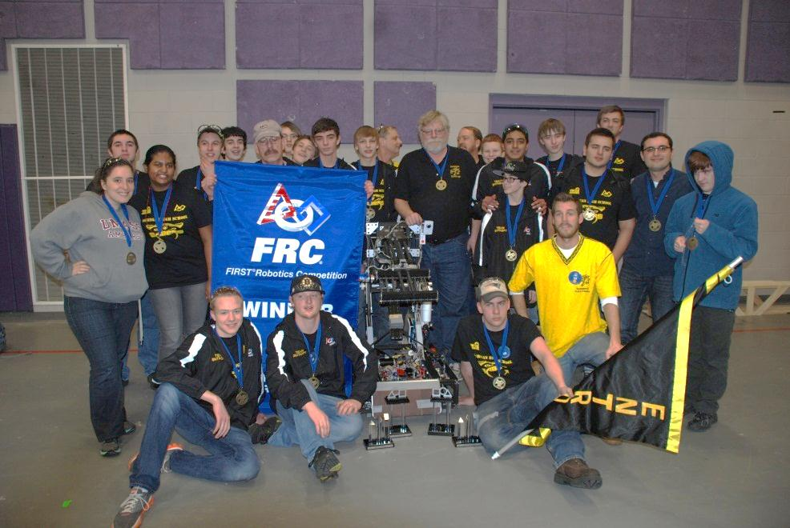

Link to competition video – GSD

 RECYCLE RUSH is a recycling-themed game played by two Alliances of three robots each. Robots score points by stacking totes on scoring platforms, capping those stacks with recycling containers, and properly disposing of pool noodles, representing litter. In keeping with the recycling theme of the game, all game pieces used are reusable or recyclable by teams in their home locations or by FIRST® at the end of the season.

Each Alliance competes on their respective 26 ft. by 27 ft. side of the playing field. Each match begins with a 15-second Autonomous Period in which robots operate independently of their drivers. During this period, robots attempt to earn points by moving themselves, their yellow totes, and their recycling containers into the area between the scoring platforms, called the Auto Zone.

During the remaining two minutes and 15 seconds of the match, called the Teleop Period, robots are controlled remotely by student drivers located behind the walls at the ends of the field. Teams on an Alliance work together to place as many totes on their white scoring platforms as possible. Alliances earn additional points for recycling containers placed on the scored totes, with containers at greater height earning more points.

Alliances also earn points for disposing of their litter in their Landfill Zone near the center of the field, or placing litter in or on scored recycling containers. Alliances that leave litter unprocessed on their side of the field at the end of the match, not in scoring position, will add points to the score of the other Alliance.

Alliances have an opportunity to earn Coopertition® points by coordinating with the other Alliance in the match. Coopertition points are awarded if, at some point in the match, there are at least four yellow totes on the step simultaneously. Coopertition points are doubled if the Alliances arrange at least four of those yellow totes in a single stack on the step.

2015 Recycle Rush Robot –Granite State District Finalist; NE Championship 5th Place; World Qualifier

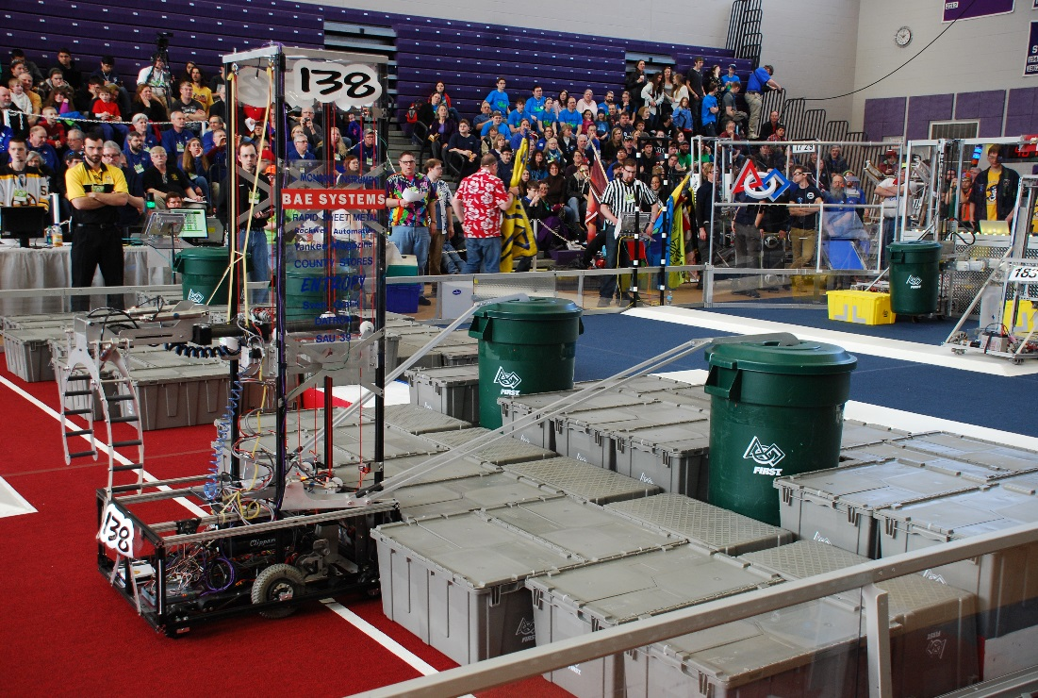

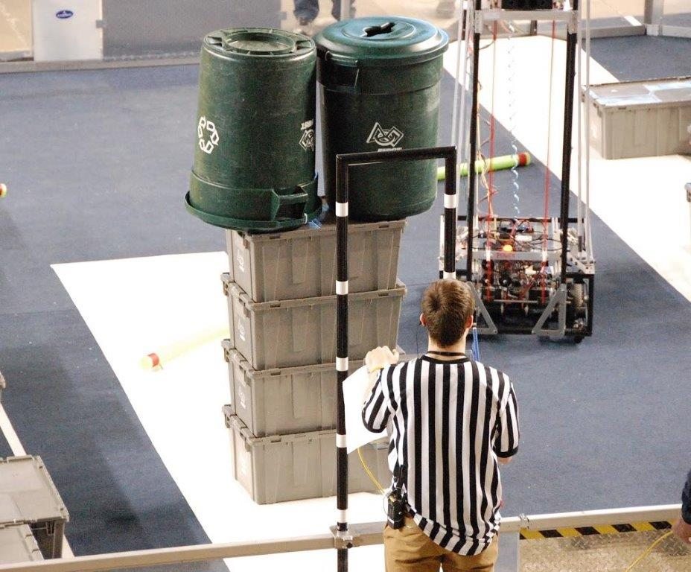Double Capper!!!

Link to UNH competition video - Double Capper (www.youtube.com/watch?v=aS1c3nN_4gM)

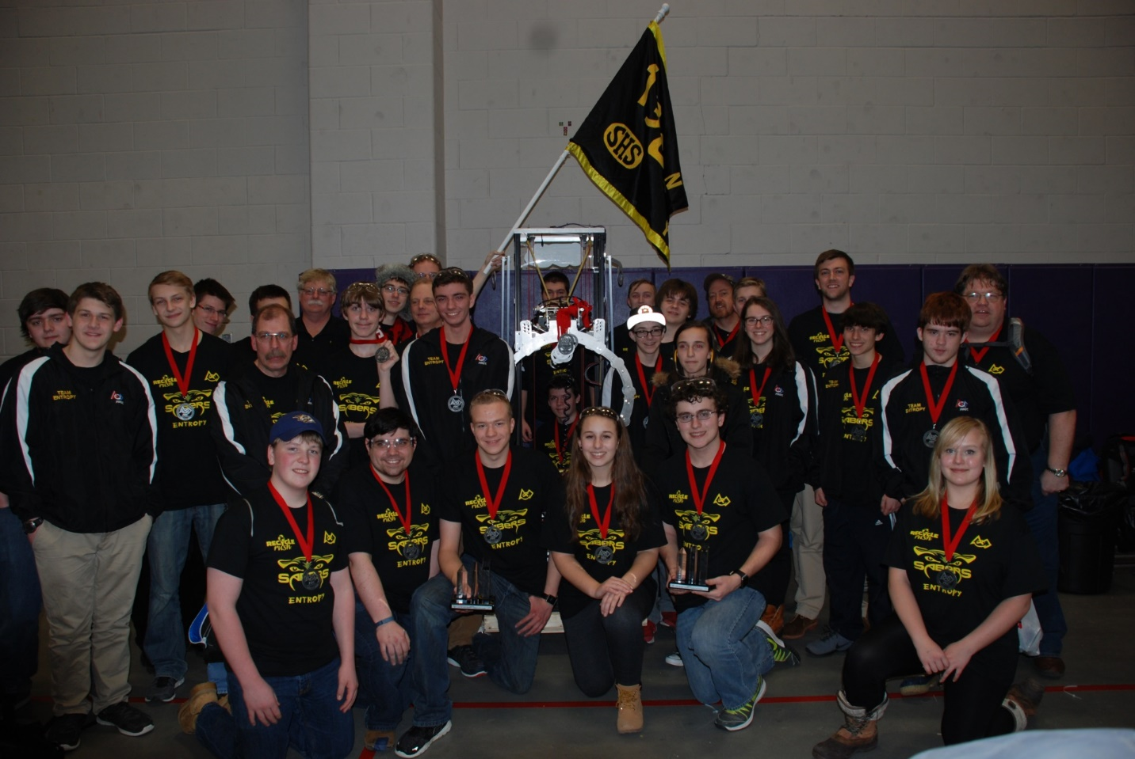

Link to NEC competition video - Autonomous Tug-of-War (www.youtube.com/watch?v=yLlSAqHkxZU)

Link to NEC competition video – Elimination Quarterfinals (www.youtube.com/watch?v=GJVnFWa6Ggk)

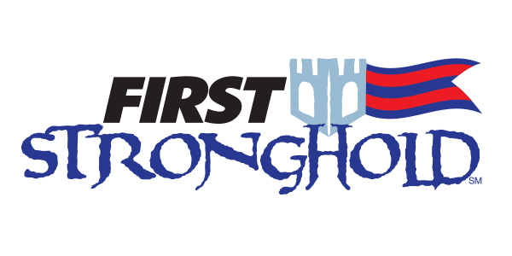FIRST STRONGHOLD is played on a 27 ft. by 54 ft. field. Each alliance commands one tower, five defenses, and a ‘secret passage’ which allows their robots to restock on ammunition, called boulders. One defense in each alliance’s set of five, the low bar, is a permanent part of the field. Three defenses are selected strategically by the alliance prior to the start of their match. The final defense changes periodically by audience selection. Each FIRST STRONGHOLD match begins with a 15-second autonomous period in which robots operate independently of human control. During this period, robots attempt to cross opposing defenses and score in the opposing tower.

2016 Stronghold Robot – NE Championship Qualifier

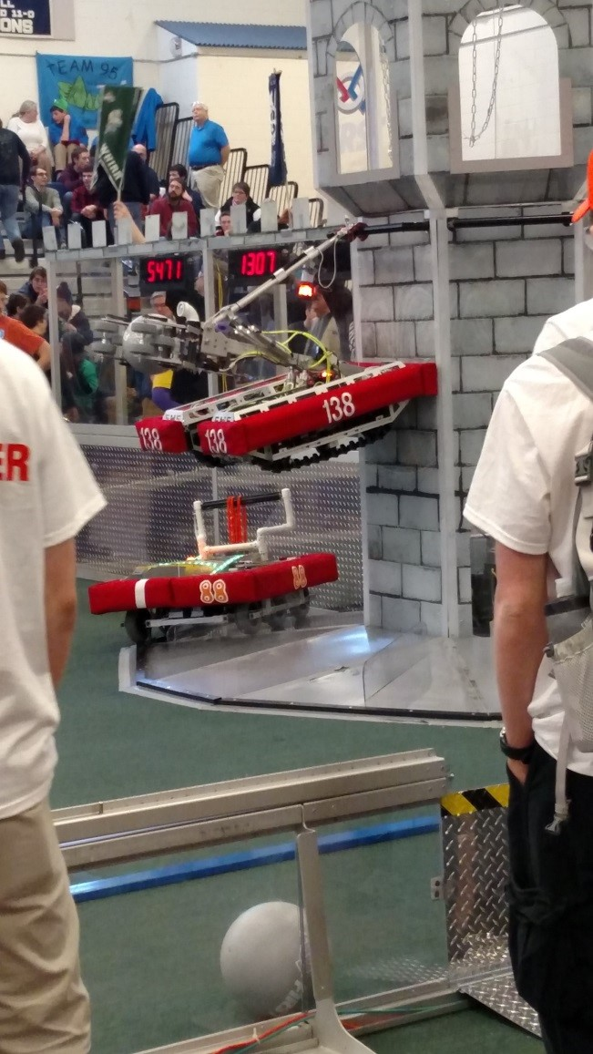

 Each match begins with a 15-second autonomous period in which robots operate only on pre-programmed instructions. During this period, robots work to support the three efforts listed above and also get points for crossing their baseline.

During the remaining 2 minutes and 15 seconds of the match, the teleoperated period, student drivers control robots. Teams on an alliance work together to build as much pressure and start as many rotors as possible – but they have to be sure they leave enough time to latch on to their airship before the end of the match.

2017 Steamworks Robot

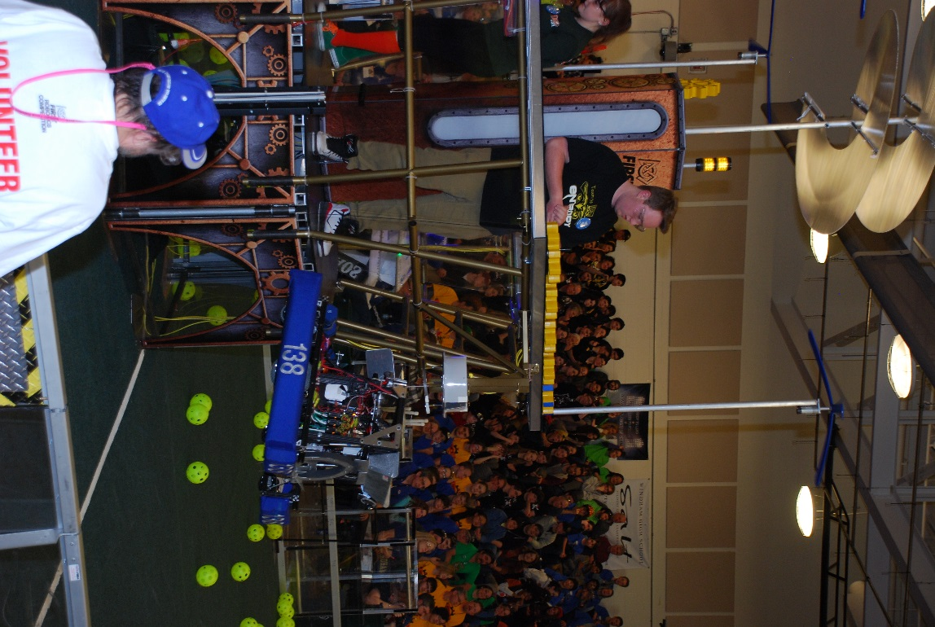

# Fundraising – 2018 Comedy Night:

Date, Location, Time, Ticket Price, & Where to Buy Tickets

Event description

List of Comedians (pictures?)

# Resources:

FIRST Resource Library - [www.firstinspires.org/resource-library](http://www.firstinspires.org/resource-library)

Chief Delphi Forums - [www.chiefdelphi.com/forums/portal.php](http://www.chiefdelphi.com/forums/portal.php)

Blue Alliance – [www.bluealliance.com](http://www.bluealliance.com)

FIRST Control System - wpilib.screenstepslive.com/s/currentCS

WPI Library Project - github.com/wpilibsuite

WPI Library Documentation - [users.wpi.edu/~bamiller/WPILib/WPILib.pdf](https://users.wpi.edu/~bamiller/WPILib/WPILib.pdf)

Getting Started with Java - wpilib.screenstepslive.com/s/currentCS/m/java

Vision Processing - wpilib.screenstepslive.com/s/currentCS/m/vision

VexPro Robotics Examples - www.vexrobotics.com/vexpro/examples-guides/?ref=tile

Team Tutorials:

CyberKnight References - [www.mhthompson.com/KingsRobotics/FRC/links.php](http://www.mhthompson.com/KingsRobotics/FRC/links.php)

Team 254 Resources - [www.team254.com/resources/](http://www.team254.com/resources/)

Team 610 Design Tutorials - [www.team610.com/wp-content/uploads/2014/03/Design-TutorialsRev10.pdf](http://www.team610.com/wp-content/uploads/2014/03/Design-TutorialsRev10.pdf)

Team 1114 Design Tutorials - [www.simbotics.org/resources/robot-design](http://www.simbotics.org/resources/robot-design)

Team 1678 Design References - [www.citruscircuits.org/robot-design.html](http://www.citruscircuits.org/robot-design.html)

# Community Engagement:

Document our support & donation to standup rookie teams in Idaho a few years ago (Bill can provide some background information).

Document our community service demos - Amherst July 4th Parade, Deland Memorial Library demo, BAE Systems Employee BBQ demo, Amherst Lions Car Show Demo, Amherst Science Fair Exhibit, Amherst Fire & Ice Demo

Town of Amherst July 4th Parade

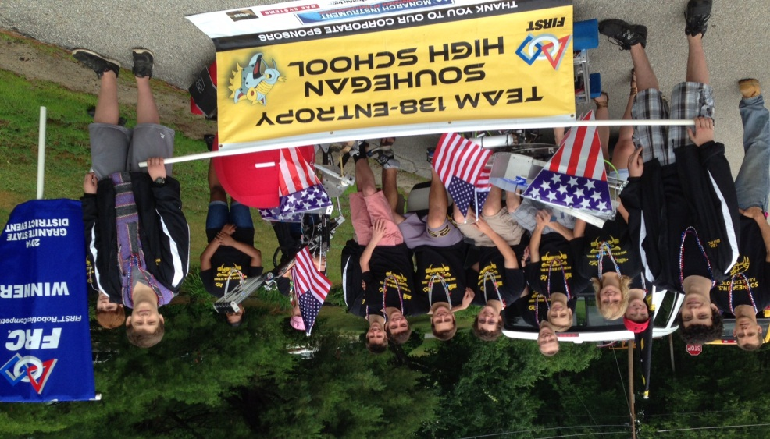

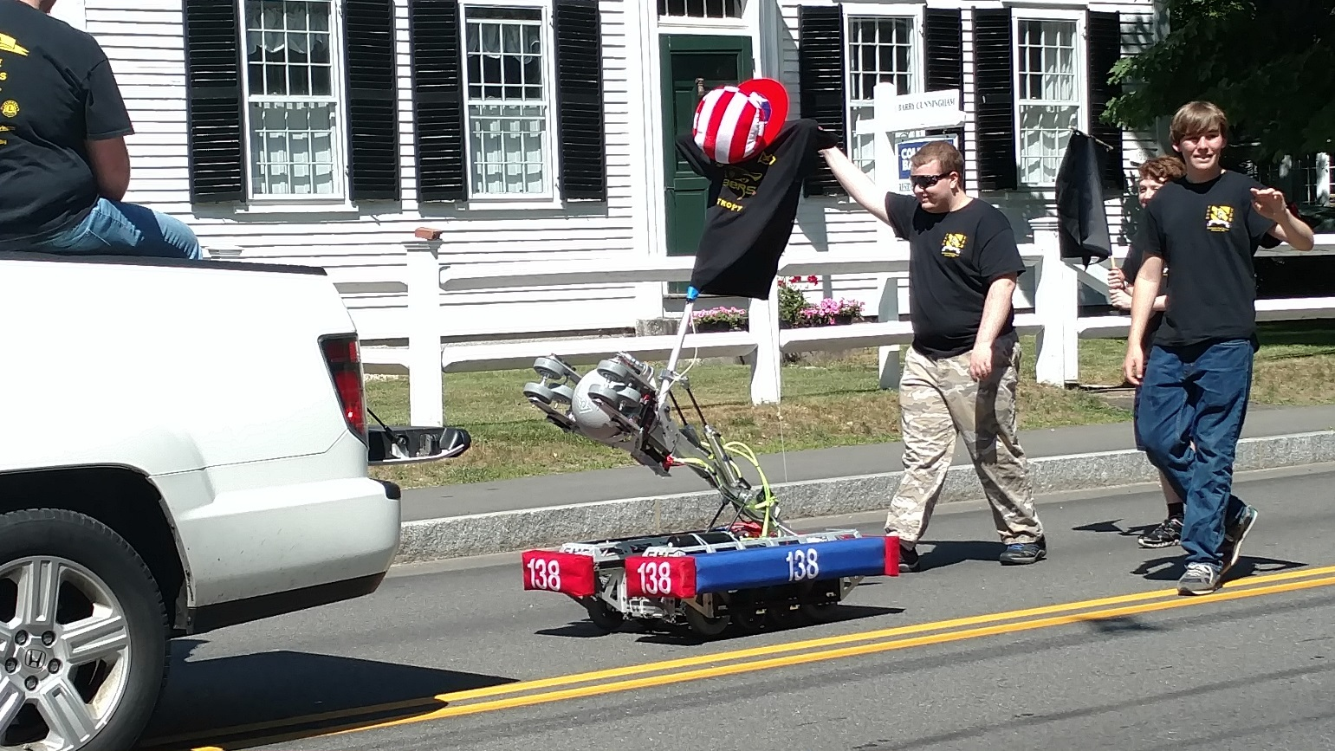

Amherst Lions “Fire and Ice” Demo promoting FIRST & SHS Robotics Team

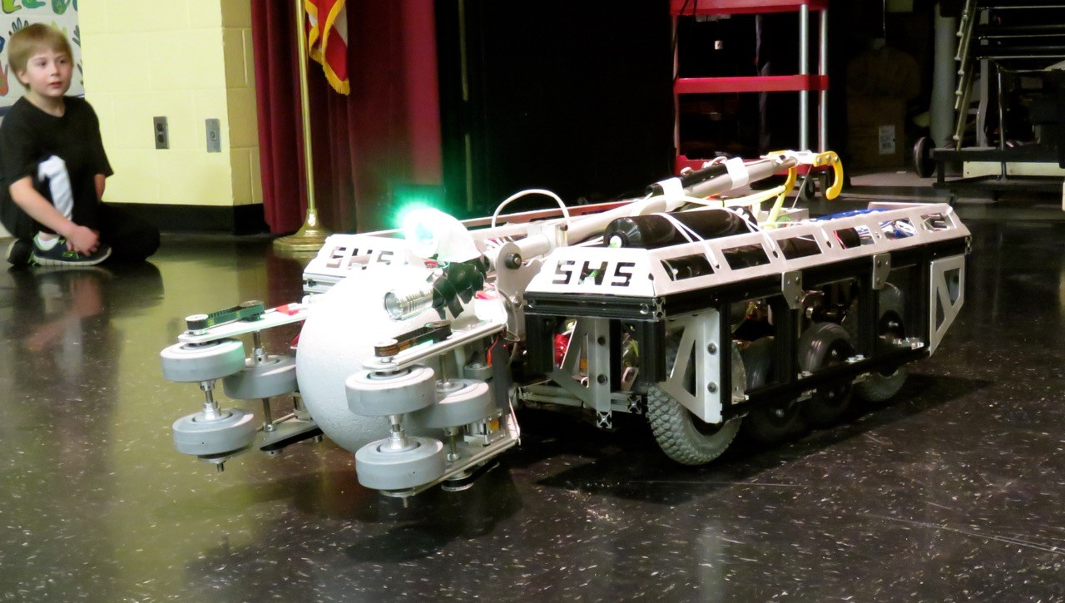

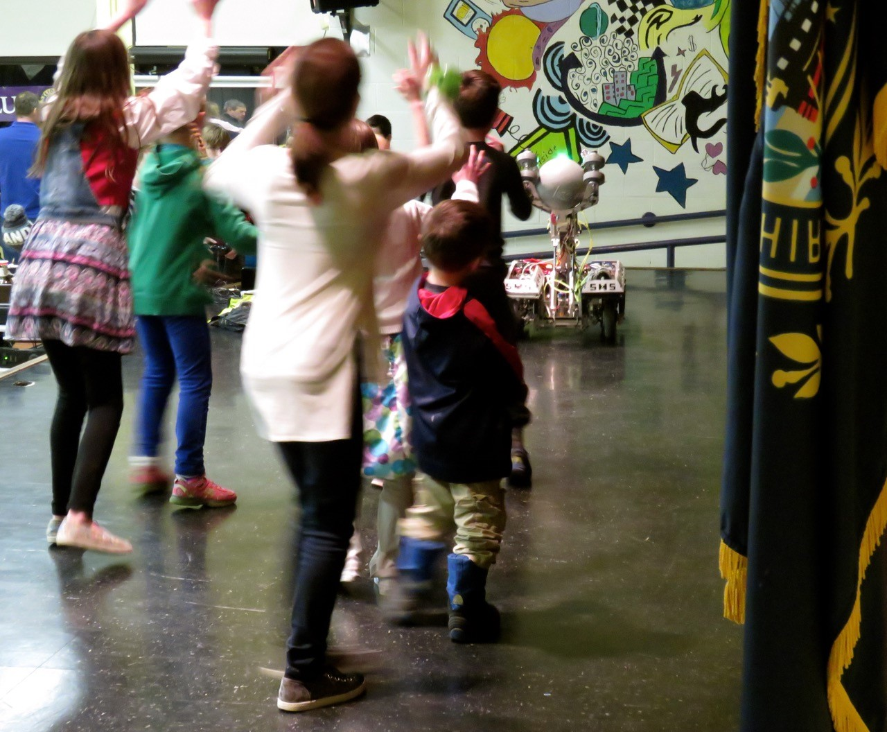

BAE Systems Summer Employee BBQ – Robot Demo

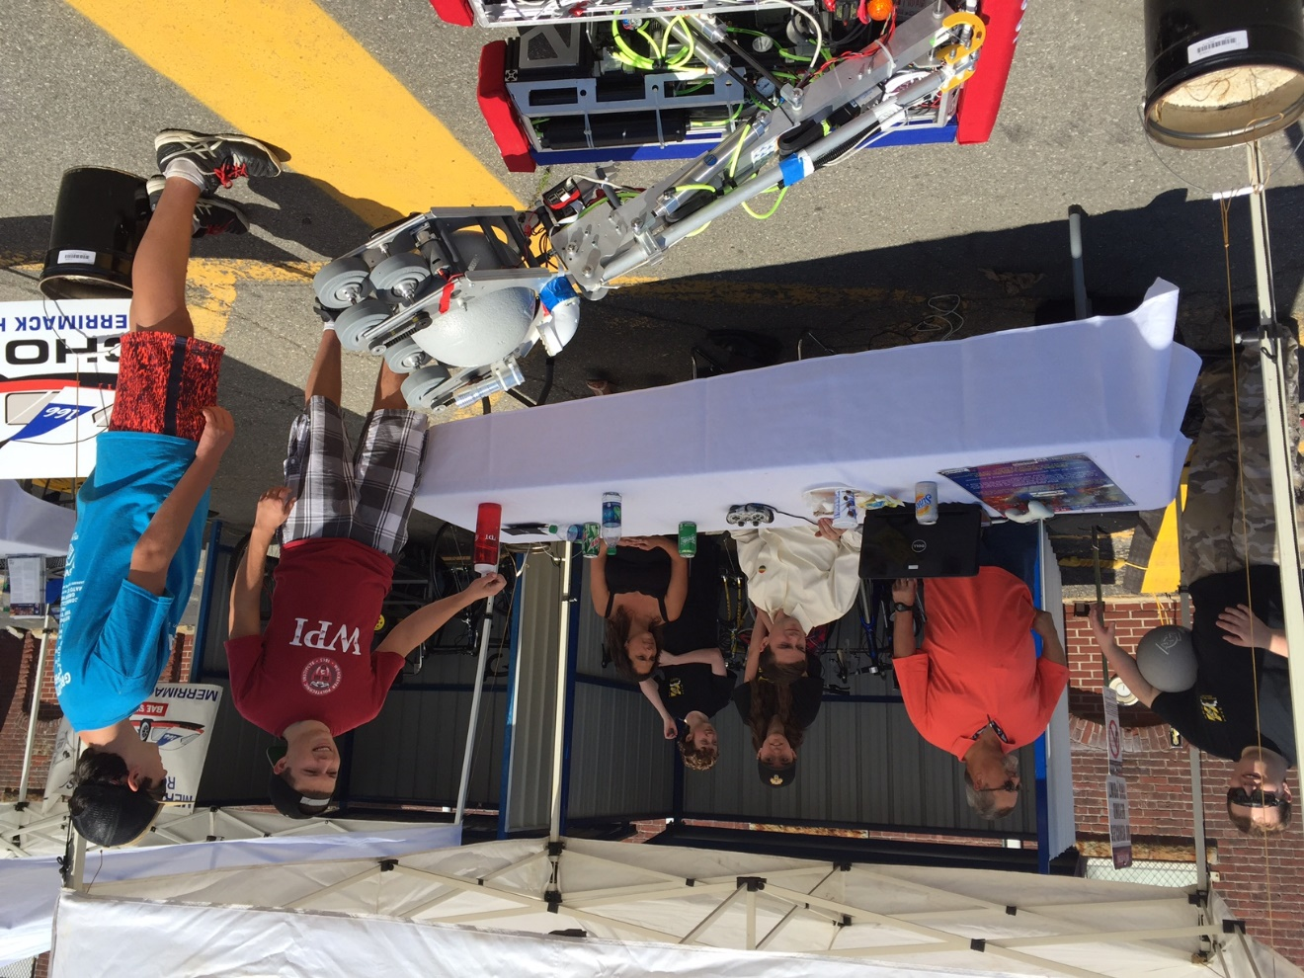

Team sharing FIRST experiences with NH Senator Kelly Ayotte

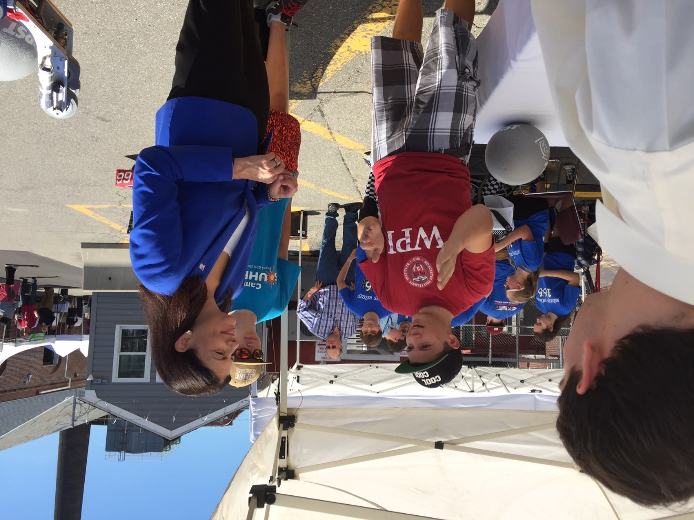

Amherst Lions Car Show – Robot Demo

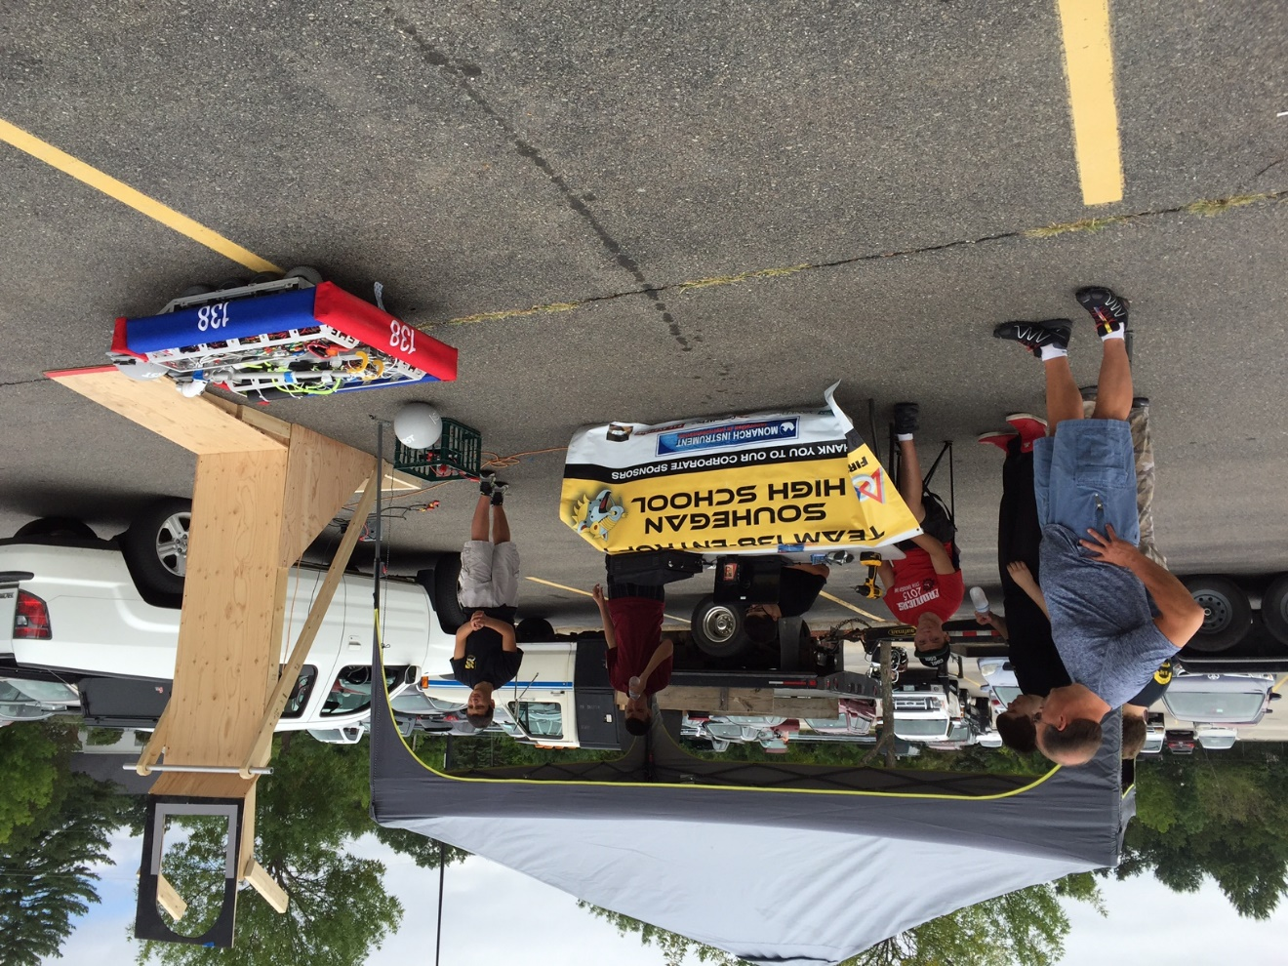

Recruiting future FIRST participants!

